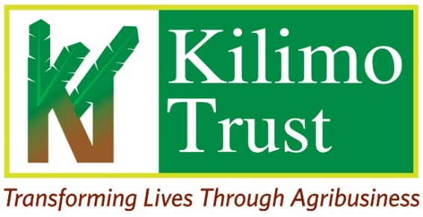

CALL FOR DIALOGUE FACILITATOR /MODERATOR - UGANDA
- About Kilimo Trust

Kilimo Trust (KT) is an independent Regional Agricultural Development Organization - working on agriculture for development across the EAC Region. It is registered in the Republic of Uganda, and it implements projects across all EAC Partner States. The core business of KT is to support the transformation of food and nutrition security in the EAC Region away from high-risk subsistence farming into lower-risk trade-based systems.
With a grant from Mastercard Foundation, Kilimo Trust is co-implementing a 5-year project titled Women and Youth Economic Empowerment in Fisheries through Inclusive Market Access (WYEEFIMA) Programme. The Programme is a Pan-African initiative led by TradeMark Africa and the Africa Continental Free Trade Area Secretariat. The programme aims to create 242,000 jobs for women and youth (aged 18-35 years) participants in seven countries. The programme is being implemented in Uganda, Kenya, Tanzania (including Zanzibar), Nigeria, Comoros, Cabo Verde, and the DRC.
Gender dynamics are central to the structure of the fish value chain. Women and youth are heavily involved in post-harvest handling, processing, and trade, yet they face numerous barriers including unequal access to finance, limited decision-making power, and socio-cultural constraints. Despite their significant contributions, the benefit of their involvement remains unequally distributed. Addressing gender disparities through targeted interventions, such as influencing policy, training, access to credit, and empowerment initiatives- can boost women’s economic outcomes and the broader resilience and inclusivity of the sector.
- About the Assignment:
Kilimo Trust is seeking to engage a consultant to facilitate inclusive, participatory, and solution-oriented dialogues among women and youth traders, aimed at identifying challenges, opportunities, and actionable solutions to improve their economic participation and empowerment.

- Scope of work
The Consultant will be responsible for ensuring the following will:
- Develop an elaborate dialogue moderation plan that especially emphasizes the voicing of views from the "vulnerable" participants.
- Facilitate interactive and inclusive discussions using participatory methods.
- Ensure active participation of women and youth especially marginalized voices.
- Harness and document key issues, solutions and key actions agreed to be taken forward in future engagements with assigned responsibilities.
- Submit the dialogue sessions report highlighting major issues for programmatic interventions.

- Expected Deliverables
The Consultant will be expected to deliver the following:
- Inception report with the dialogue facilitation plan
- Final report with outcomes, participant feedback and recommendations for pragmatic interventions.

- Duration, Timeline and Reporting
The assignment will be billed for a total of Three (3) working days, to be undertaken between 1st – 5th December 2025. The exact commencement date will be confirmed upon signing the contract.
- Location:
Kilimo Trust will convene stakeholder dialogues on 3rd December 2025 in Jinja City, Uganda.

- Technical Requirements:
The consultant (individual or firm) must meet the following minimum qualifications:
- A degree in community development, social work, gender studies, communication and public relations and other related fields. An advanced degree will be an added advantage.
- Recognized certification in training of trainers, facilitation or group dynamics is an added advantage.
- Evidence of being an excellent facilitator or trainer of women and or youth groups, networks and or cooperatives.
- Familiarity with the informal sector dynamics is an added advantage.

- Mode of Application.
All Interested Vendors must submit online via email to recruitment@kilimotrust.org Technical and Financial Proposals, CVs, three reference letters from their clients, and proof of conducting similar assignments by Friday, October 24, 2025, 16:00hrs
The Prospective vendor MUST indicate in the Email subject “Dialogue Facilitator/Moderator-Uganda.”
“Only successful bidders shall be contacted. If you do not hear from us within one (1) week after the bid submission deadline, consider your bid unsuccessful. “

